**PLOTS OF VARIOUS ENERGY STATES**:

SOURCE CODE:

**clc**

clear

clf

for i=1:4

E=input("Enter Energy eigenvalue:")

function **dy**=f(**r**, **x**)

e=3.795; m=0.511*10^6; h=1973;

**dy**(1)=**x**(2)

**dy**(2)=(2*m/(h*h))*(-((e*e)/**r**)-E)\***x**(1)

endfunction

if (i==1|i==2) then

r=0.01:0.01:10

else

r=0.01:0.01:20

end

u= ode([0.01;1],0.01,r,f);

subplot(2,2,i)

plot(r',u(1,:))

if(i==1)

title("Ground state")

else

title("Excited state"+string(i-1))

end

a=gca()

a.x_location="origin"

a.y_location="origin"

xlabel('r',"fontsize",4);ylabel('u(r)',"fontsize",4)

end

OUTPUT:

Enter Energy eigenvalue:-13.59559

Enter Energy eigenvalue:-3.4

Enter Energy eigenvalue:-1.511

E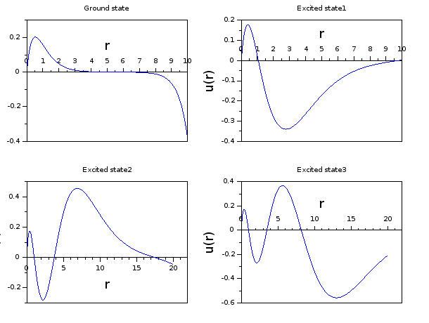nter Energy eigenvalue:-0.85